**Ideas mandatory attachments**

User interface ideas (in order of priority)

1. To avoid a lot of changes in manuals a very quick an easy fix could be to add an image of a paperclip in the ‘Bijlagen’-header. That way we don’t have to change the text: Click on the paperclip. (> print screen)
2. In our opinion the text “Bijlagen voor aanvragen” is redundant. On the top of the form the activity is already indicated. (> print screen)

Furthermore it fixes the problem of “Bijlagen voor Onbekende Activiteit” because its already indicated that this is an automatically generated document. (> print screen)

1. The button “uploaden” is not user friendly and counter intuitive. Especially when you forgot to press it and you get an error. We would prefer it if in the future is automatically integrates when you press the activity-button. (> print screen)
2. A “nice-to-have” would be to change “verwijderen” in to an image of  (> print screen)
3. When you add an attachment another field is presented automatically above. A “nice to have” would be a  instead which only gives you another field if necessary. (> print screen)

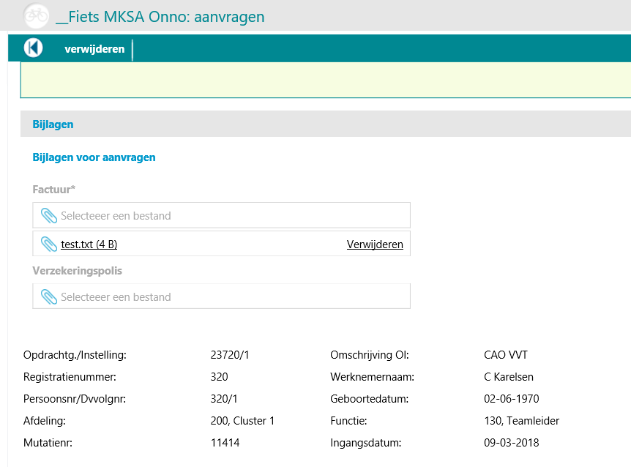

2

1

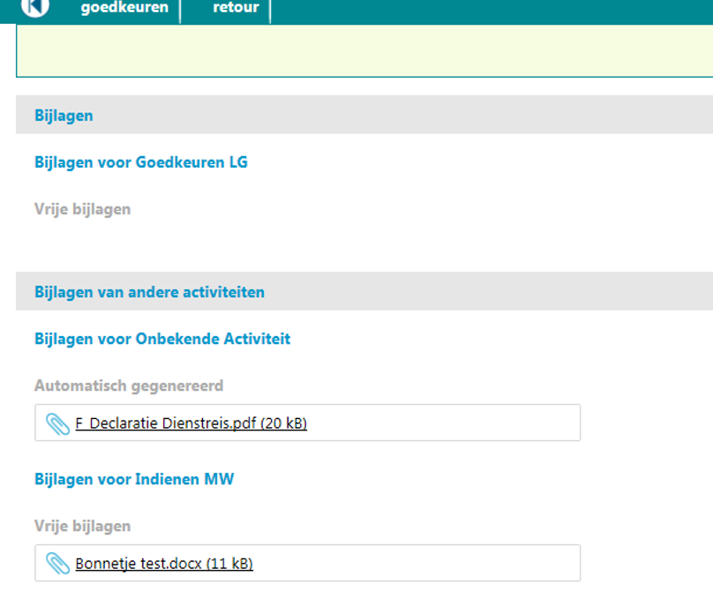

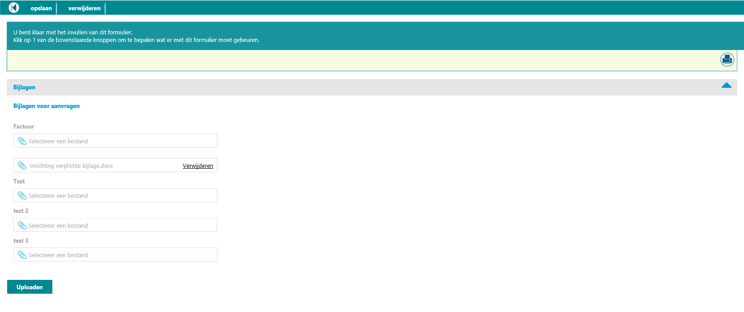

5

3

4